CFS VIP 26 webUI where it is connected to RFS VIP 27

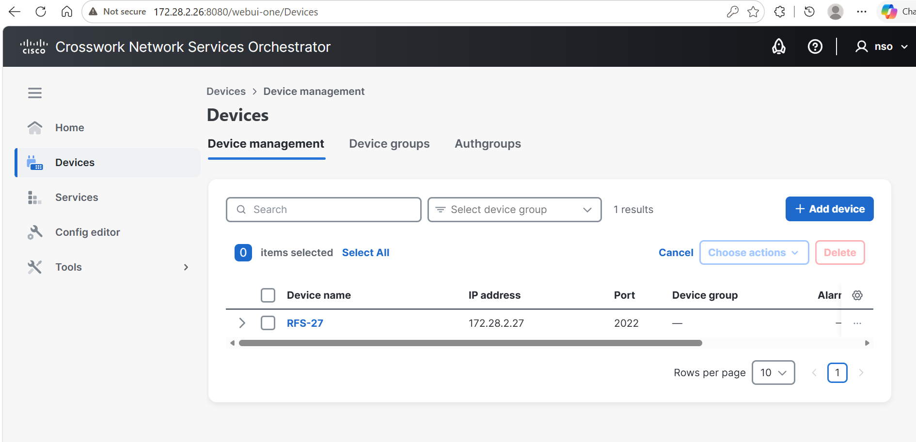
HA
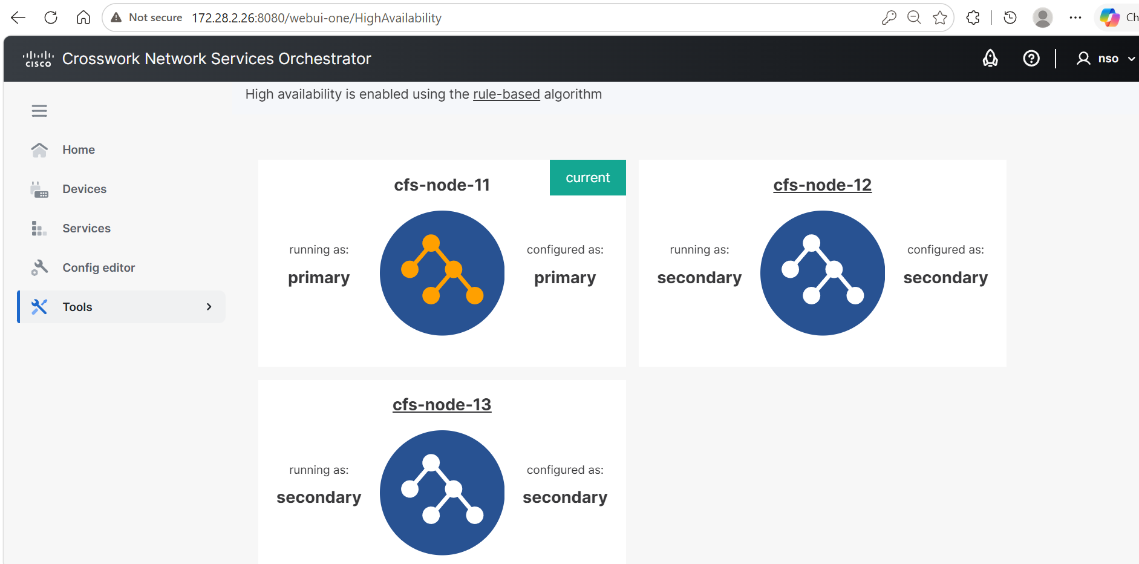

Ssh to CFS VIP 172.28.2.26
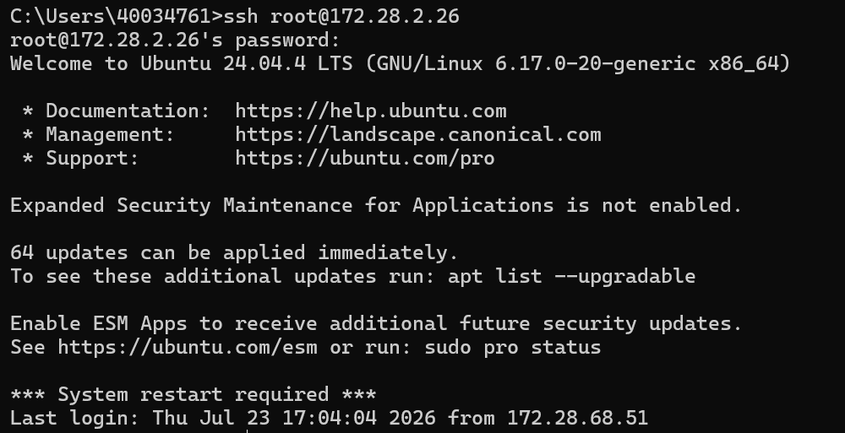
ncs –status of CFS VIP 172.28.2.26
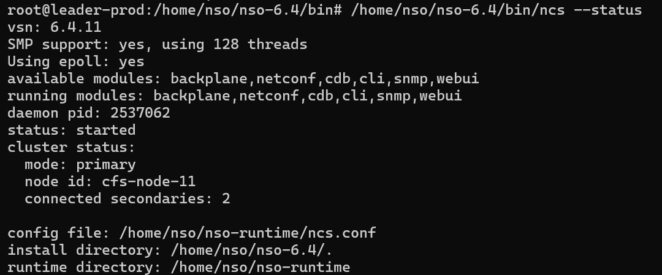

Devices list of CFS VIP 172.28.2.26
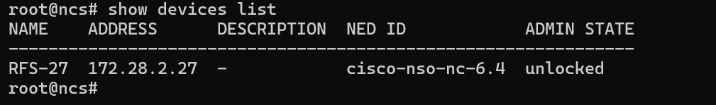
Device connect to VIP of RFS-27 from CFS-26
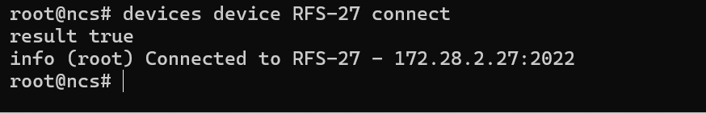
Device sync-from CFS VIP 26 to RFS VIP 27
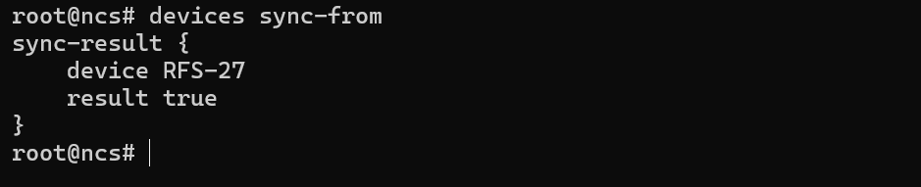

Ssh to RFS 172.28.2.27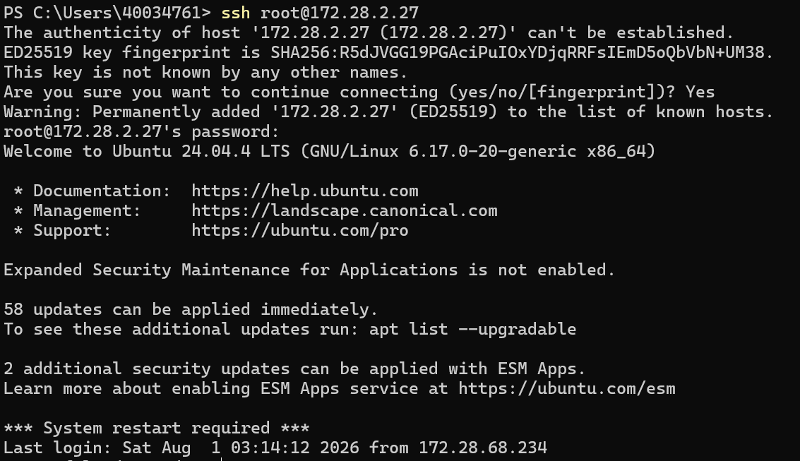

ncs –status of CFS RFS VIP 172.28.2.27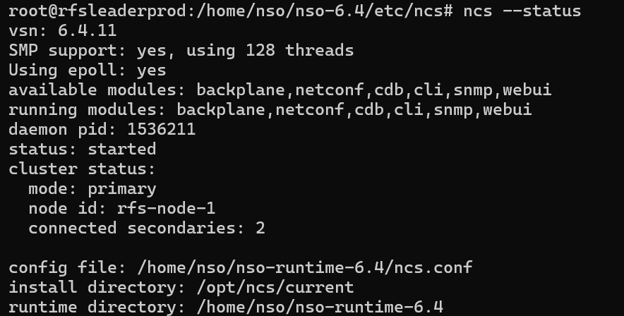

Devices list of VIP RFS-27
